***TASK 1***

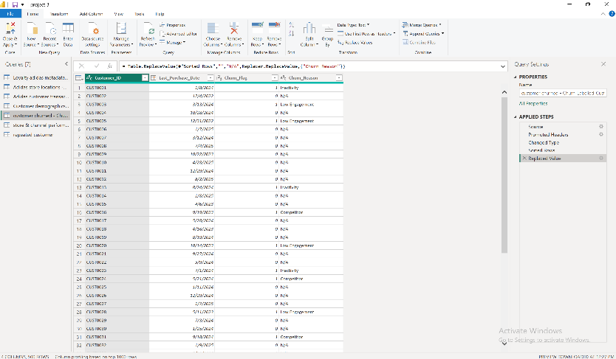

***TASK 2***

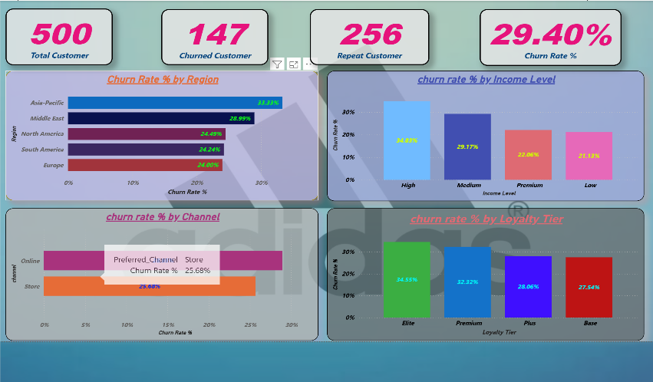

* Churned Customer = CALCULATE(DISTINCTCOUNT('customer churned - Churn_Labelled_Customers (1)'[Customer_ID]),'customer churned - Churn_Labelled_Customers (1)'[Churn_Flag]=1)
* Repeat Customer = CALCULATE(DISTINCTCOUNT('Adidas customer transactional  - Customer_Transactions (1)'[Customer_ID]),FILTER('Adidas customer transactional  - Customer_Transactions (1)',CALCULATE(COUNTROWS('Adidas customer transactional  - Customer_Transactions (1)'),ALLEXCEPT('Adidas customer transactional  - Customer_Transactions (1)','Adidas customer transactional  - Customer_Transactions (1)'[Customer_ID]))>1))
* Total Customer = DISTINCTCOUNT('customer churned - Churn_Labelled_Customers (1)'[Customer_ID])
* Churn Rate % = DIVIDE([Churned Customer],[Total Customer],0)

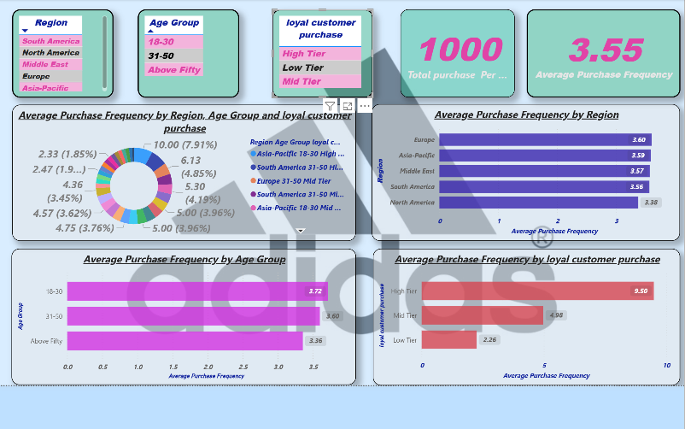 ***TASK 3***

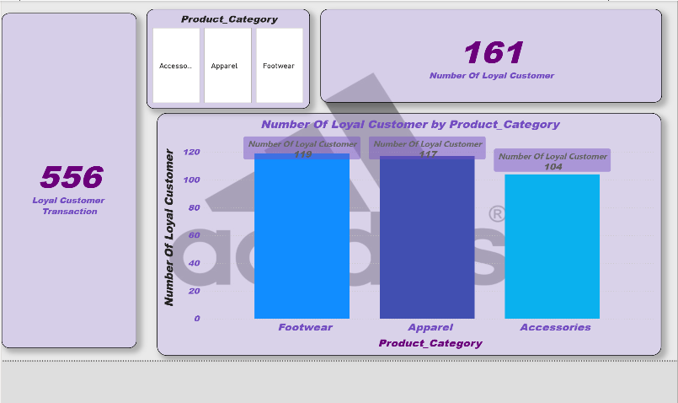

* Average Purchase Frequency = DIVIDE(COUNTROWS('Adidas customer transactional  - Customer_Transactions (1)'),DISTINCTCOUNT('Adidas customer transactional  - Customer_Transactions (1)'[Customer_ID]),0)
* loyal customer purchase = IF('NO OF ORDER'[Average Purchase]<4,"Low Tier",IF('NO OF ORDER'[Average Purchase]<=8,"Mid Tier","High Tier"))
* Number Of Loyal Customer = CALCULATE(DISTINCTCOUNT('Adidas customer transactional  - Customer_Transactions (1)'[Customer_ID]),FILTER('Loyalty adidas metadata - Loyalty_Program (1)','Loyalty adidas metadata - Loyalty_Program

***TASK 4***

* ***TASK 4 DAX MEASURES FORMULA***
* Promo Transaction = CALCULATE(COUNTROWS('Adidas customer transactional  - Customer_Transactions (1)' ),'Adidas customer transactional  - Customer_Transactions (1)'[Promotion_Applied]="yes")
* Promo Transaction Percentage = DIVIDE('promotion used'[Promo Transaction],'promotion used'[Total Transaction],0)
* Non Promo Transaction = CALCULATE(COUNTROWS('Adidas customer transactional  - Customer_Transactions (1)' ),'Adidas customer transactional  - Customer_Transactions (1)'[Promotion_Applied]="No")
* Non Promo Transaction Percentage = DIVIDE('promotion used'[Non Promo Transaction],'promotion used'[Total Transaction],0)
* Total Transaction = COUNTROWS('Adidas customer transactional  - Customer_Transactions (1)')

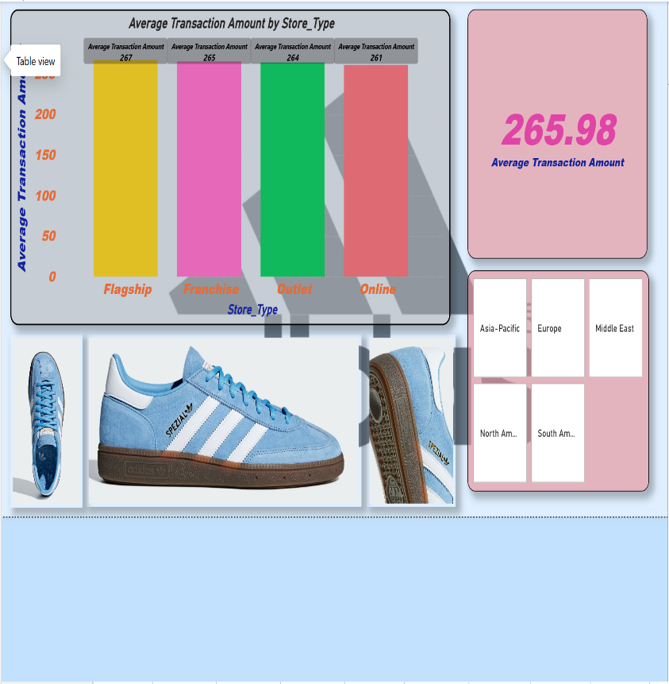***TASK 5***

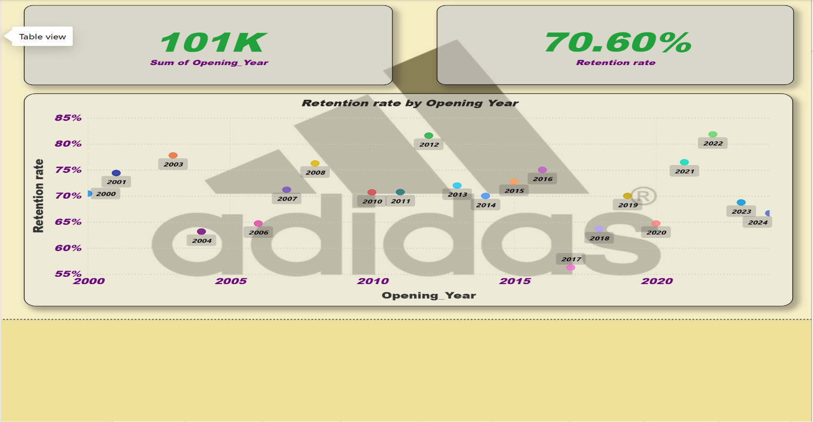

* *TASK 5 DAX MEASURES FORMULA*
* Average Transaction Amount = AVERAGE('store & channel performance vs retention'[Amount])
* Retention rate = DIVIDE(COUNTROWS(FILTER('customer churned - Churn_Labelled_Customers (1)','customer churned - Churn_Labelled_Customers (1)'[Churn_Flag]=0)),COUNTROWS('customer churned - Churn_Labelled_Customers (1)'))

***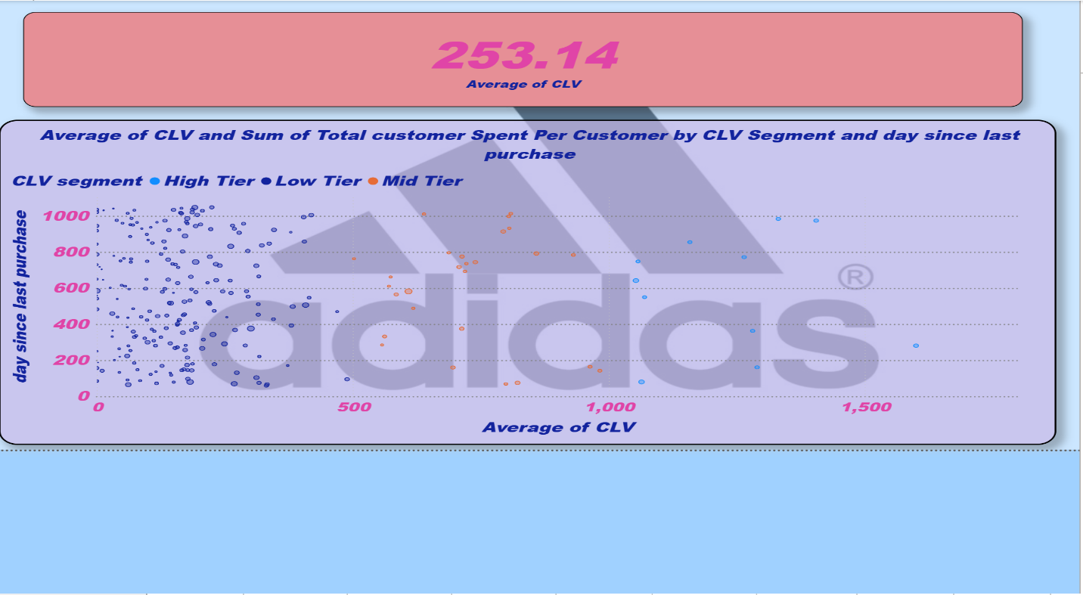******TASK 6***

* ***TASK 6 DAX MEASURE FORMULA***
* ***CLV = DIVIDE([Total customer Spent Per Customer],'Customer demographics adidas - Customer_Demographics (1)'[Membership Duration (Year)],0)***
* CLV Segment = SWITCH(TRUE(),'Customer demographics adidas - Customer_Demographics (1)'[CLV]<500,"Low Tier",'Customer demographics adidas - Customer_Demographics (1)'[CLV]<1000,"Mid Tier","High Tier")
* day since last purchase = DATEDIFF('customer churned - Churn_Labelled_Customers (1)'[Last_Purchase_Date],TODAY(),DAY)

***TASK 7 PAGE (1)***

***TASK 7 PAGE (2)***

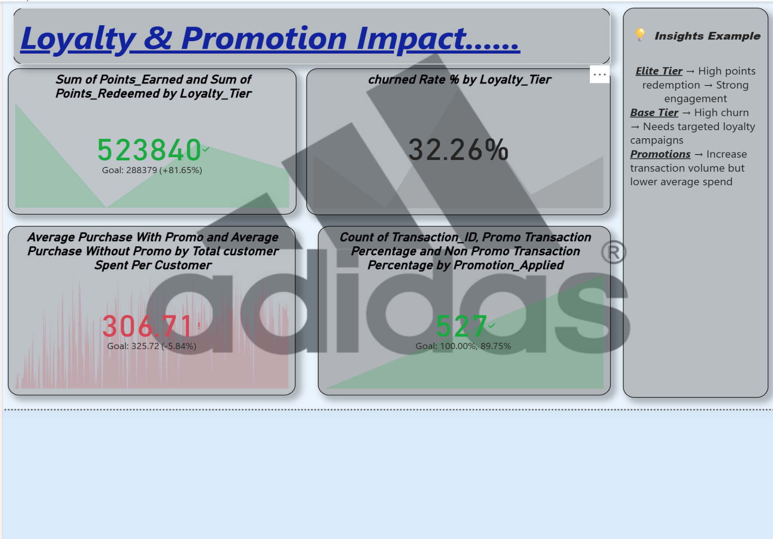

***TASK 7 PAGE (3)***

***TASK 4 PAGE (4)***

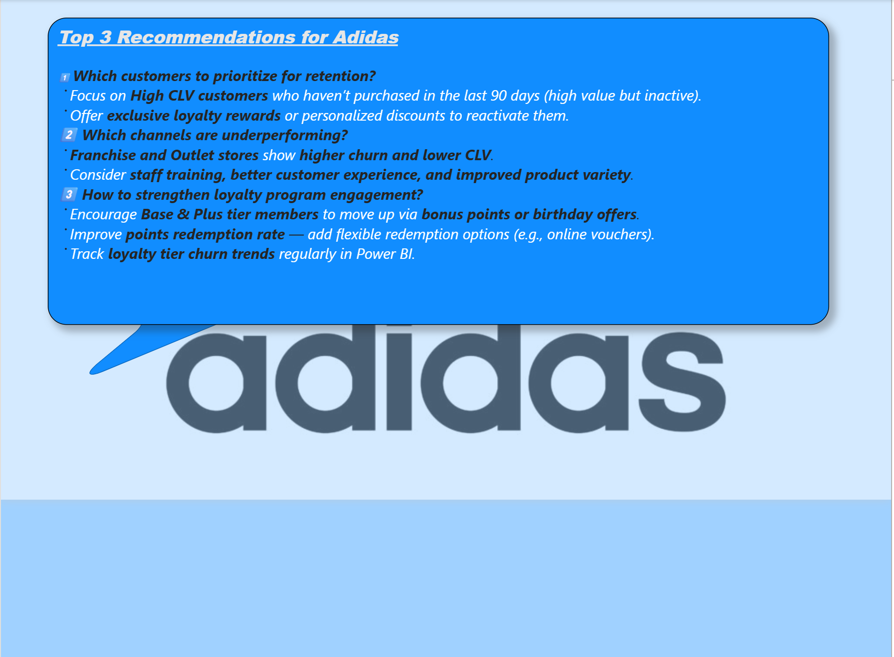***TASK 4 PAGE (5)***

<https://www.loom.com/share/fb36f8268e234bf1a6f216de7611ef74?sid=6977c13f-6589-4de5-9549-0608d1158375>

<https://www.loom.com/share/9149d1297fa0464f908ab8a8d4483ea6?sid=beed2a4b-c55f-4d7d-b988-d3d39e55eca4>

<https://www.loom.com/share/798d701488994fd4a265452d55d83ab1?sid=2e517a28-4be3-45db-818c-2454fab34bf2>